AI-Assisted Logistics Customer Service
Student Name: RITIK SHARMA
Roll Number: 2620994562
Batch:BBA LSCM I BATCH
Date: 8 October 2026
AI Tool Used: ChatGPT
Prompt used - Write a customer message about a delayed shipment.

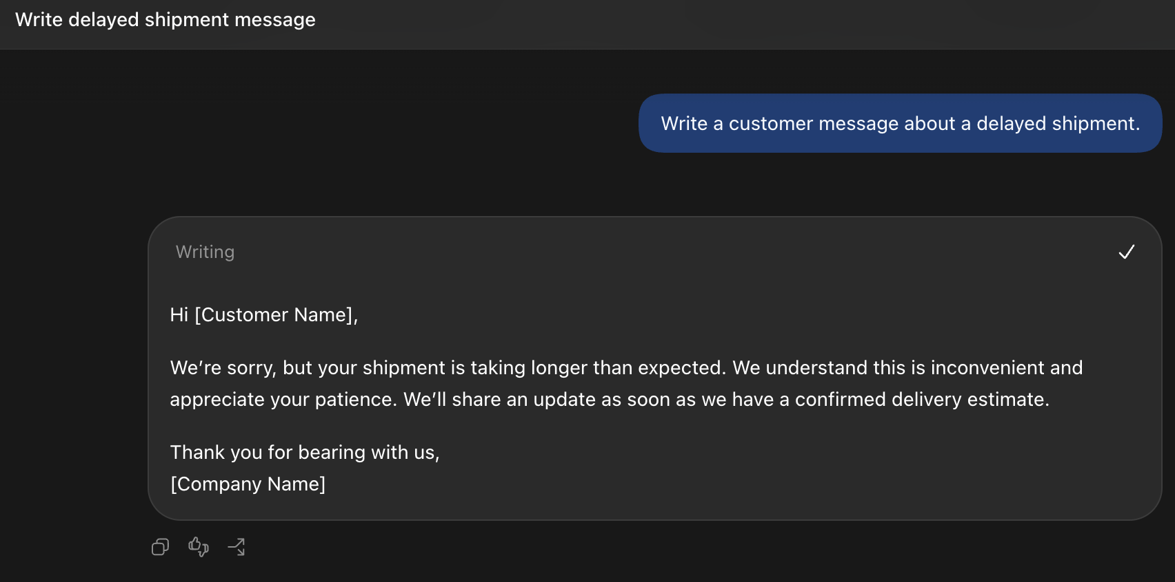

Observation:
The response is polite and easy to understand, but it is too general. It does not identify the shipment or provide the specific delay reason and revised delivery time.
Two limitations identified:
- It does not mention the shipment ID FR208 or identify the specific shipment.
- It does not provide the actual delay reason, revised estimated delivery time, or next update time.
ROUND 2 -Context and Constraints
Prompt used - Company: FreshRoute Logistics
Shipment ID: FR208
Customer: GreenBasket Retail
Goods: 100 cartons of packaged biscuits
Route: Delhi warehouse → Jaipur retail distribution centre
Scheduled delivery: 12 October 2026, 10:00 AM
Revised estimated delivery: 12 October 2026, 4:00 PM
Delay reason: Vehicle breakdown during transit
Recovery action: A replacement vehicle has been arranged; cargo transfer is in progress
Next customer update: 12 October 2026, 1:00 PM
Fictional company policy: For a delay of four hours or more, the customer may request a delivery-fee review. A refund is not automatic and requires approval
Assistance: Customers can contact the logistics support desk
Information not provided: Delivery fee, refund amount, driver contact number, live vehicle location and confirmed cargo condition
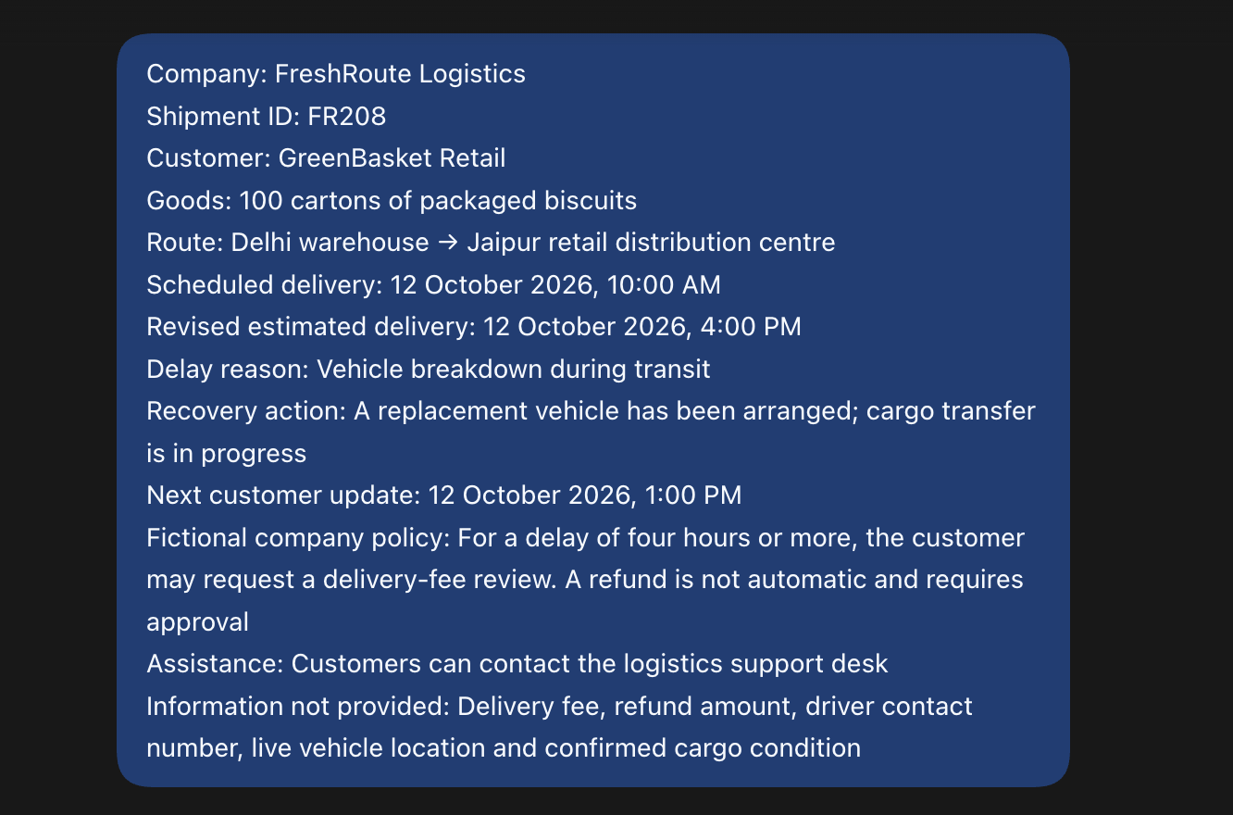
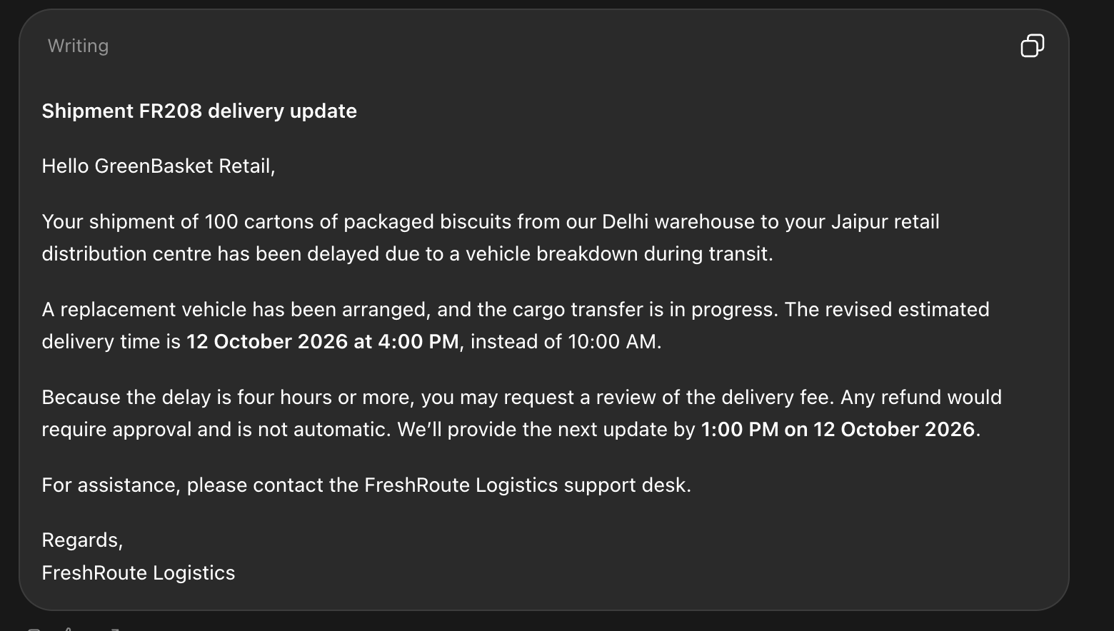

Observation:
The response is more specific and useful than the Round 1 response because it includes the shipment ID, delivery times, delay reason, recovery action and next update. It also clearly treats the revised delivery time as an estimate and explains that a refund is not automatic.

Two improvements compared with Round 1:
- The response uses the supplied shipment facts instead of giving a generic delay message.
- It avoids unsupported information and clearly distinguishes the estimated delivery time from a guaranteed delivery time.

Round 3: Role Prompting
Prompt Used:
Act as a logistics customer service executive at FreshRoute Logistics. Rewrite the previous email in a calm, respectful and accountable tone. Acknowledge that the delay may affect the customer’s planning. Preserve all supplied facts, stay within 120 words and do not add promises or unverified information.

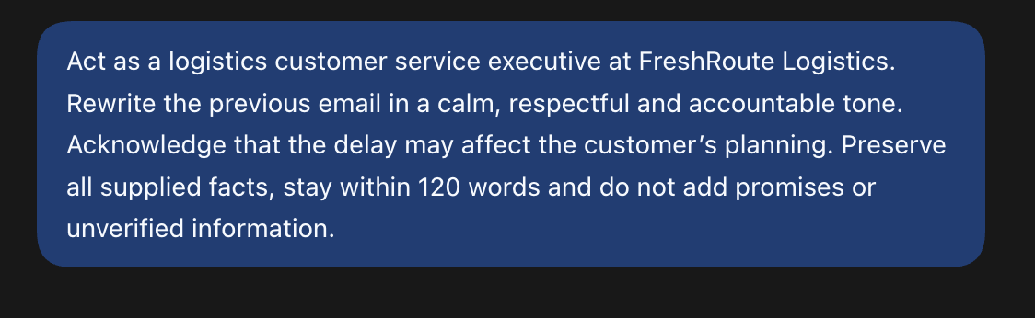
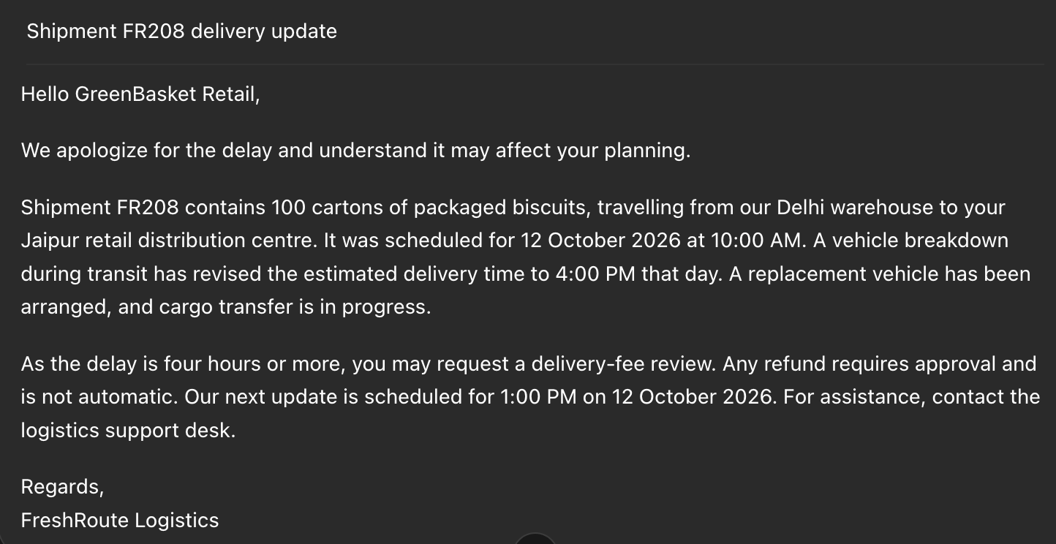

OBSERVATION:
The response has a calmer and more respectful tone than the previous version. It acknowledges that the delay may affect the customer’s planning while keeping the supplied facts unchanged.

Useful change in tone:
The AI made the message more empathetic and accountable by acknowledging the inconvenience caused by the delay, while still keeping the communication professionaL

Round 4: Few-Shot Prompting
Prompt Used:
Follow the concise question-and-answer style of these examples:
Customer: “What is my shipment reference?”
Response: “Your shipment reference is FR208.”
Customer: “When will I receive the next update?”
Response: “Your next update is scheduled for 12 October 2026 at 1:00 PM.”
Now answer these questions using only the supplied shipment information:
- Why is my shipment delayed?
- What is being done to recover the shipment?
- Will I automatically receive a refund?
- Can you confirm that all cartons are undamaged?
Keep each answer within two sentences. If information is unavailable, state that clearly and refer the customer to the logistics support desk. Do not invent details.

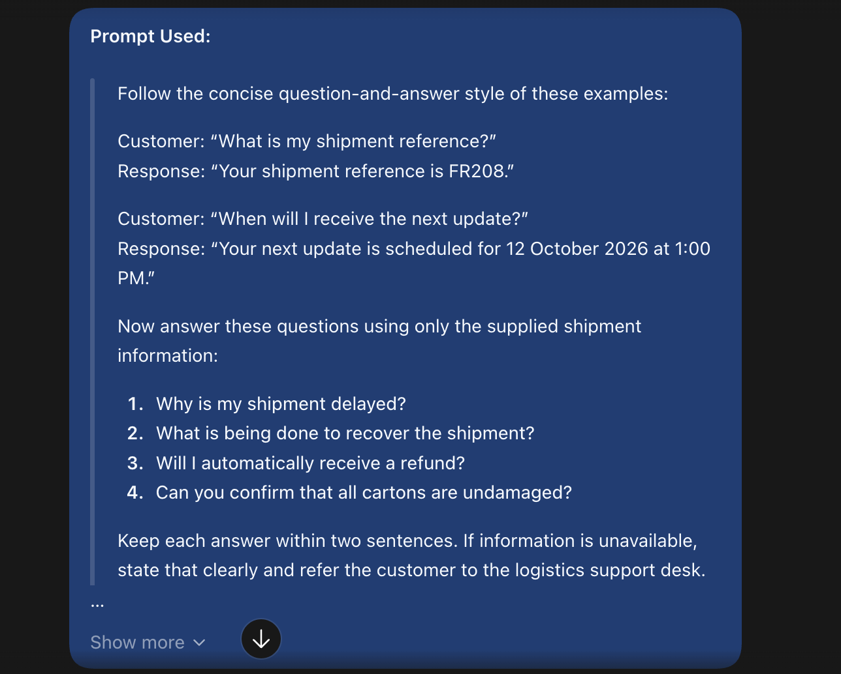
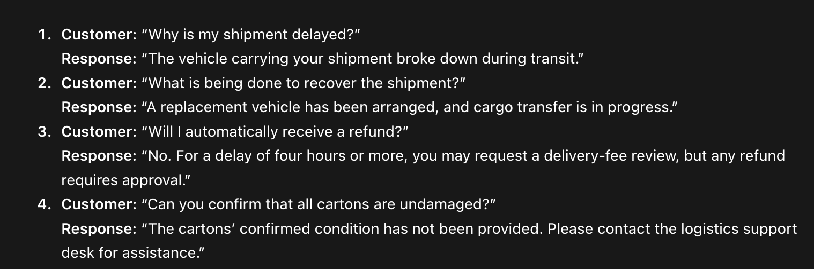
Observation:
The examples guided the AI to use a concise question-and-answer format. The response followed the same pattern and clearly separated each customer question from its answer.
Effect of Few-Shot Examples:
The examples helped the AI keep the answers short, direct and consistent. They also encouraged it to avoid guessing when information such as cargo condition was not provided.

Round 5: Structured-Output Prompting
PROMPT USED - Using only the supplied shipment facts and fictional policy, create a table with three columns: Customer Question, Answer Based on Supplied Information, and Missing Information or Approval Needed.
Answer these questions:
- When was delivery originally scheduled?
- What is the revised estimated delivery time?
- Why is the shipment delayed?
- What recovery action is underway?
- How much refund will I receive?
- Where is the vehicle currently located?
Write “Not provided” where information is unavailable. Write “None” in the final column when no additional information is needed to answer the question. Do not guess.

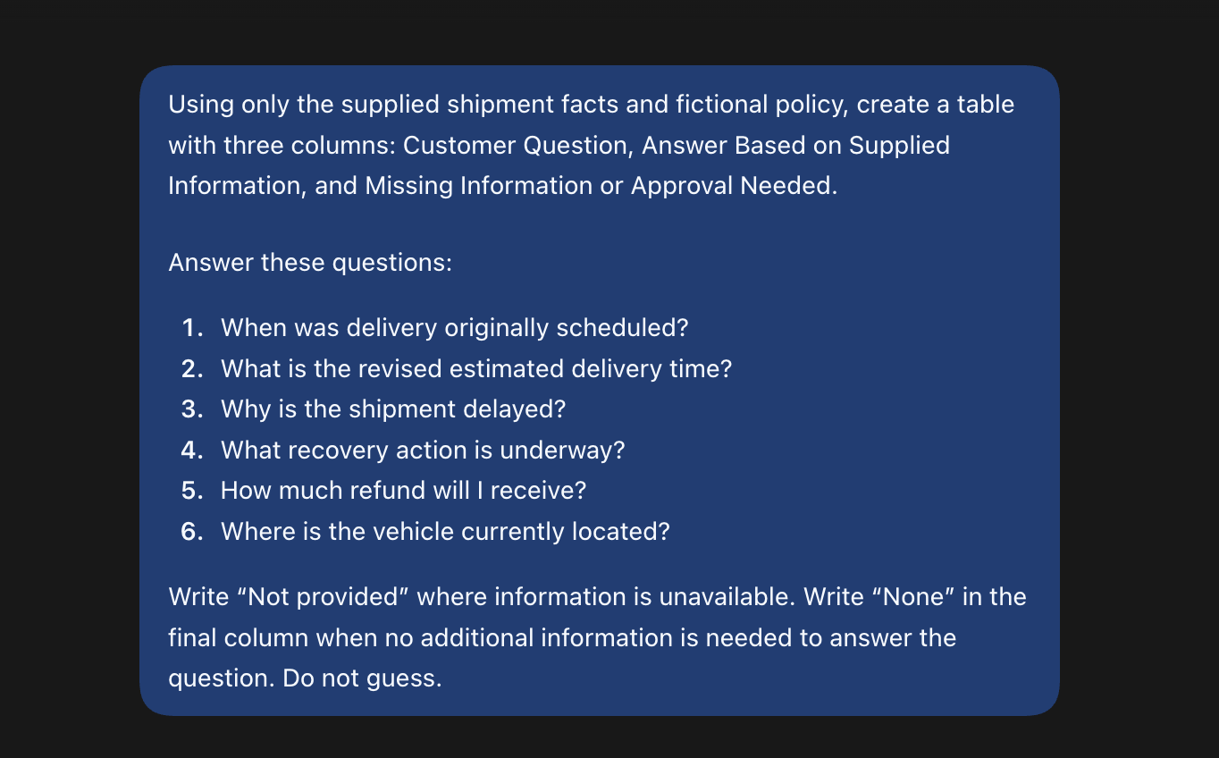

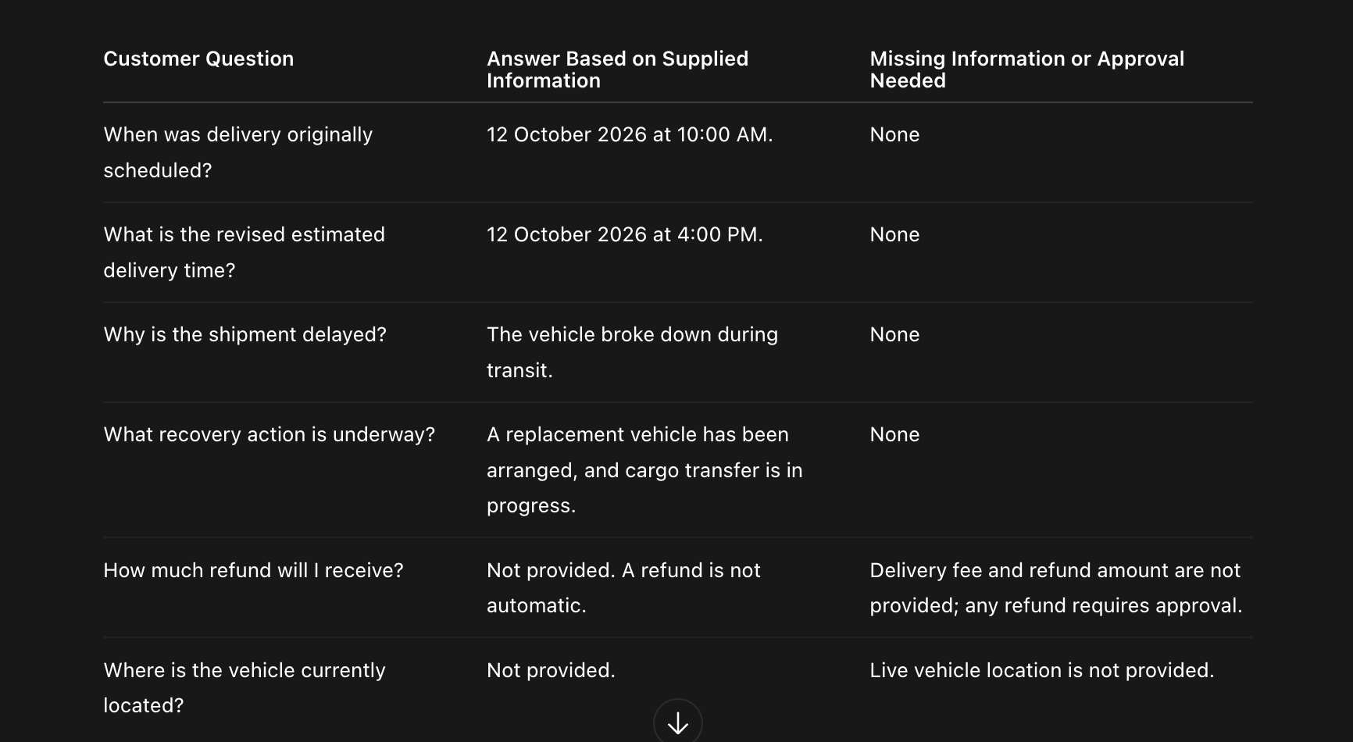

Observation:
The table is easier to review than a paragraph because each customer question and its answer are clearly separated. It also makes missing information and approval requirements easy to identify.

Use for Customer Support:
This table can help a customer support employee quickly find verified answers and avoid giving customers incorrect or unconfirmed information.

Round 6: Audience-Based Prompting
PROPMT USED - Using the supplied shipment information, create:
A. A customer SMS within 50 words, including shipment ID, revised estimated delivery and next update.
B. An internal briefing within 100 words for the warehouse coordination team, including shipment quantity, route, delay reason, recovery action and key unknowns requiring confirmation.
Label the two outputs clearly. Keep facts consistent. Do not invent a new recovery action, cargo condition or delivery guarantee.

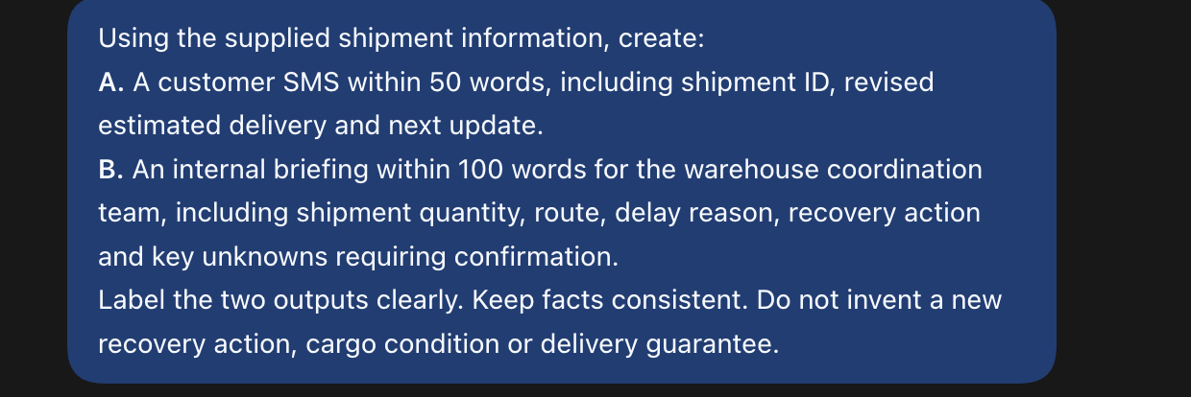
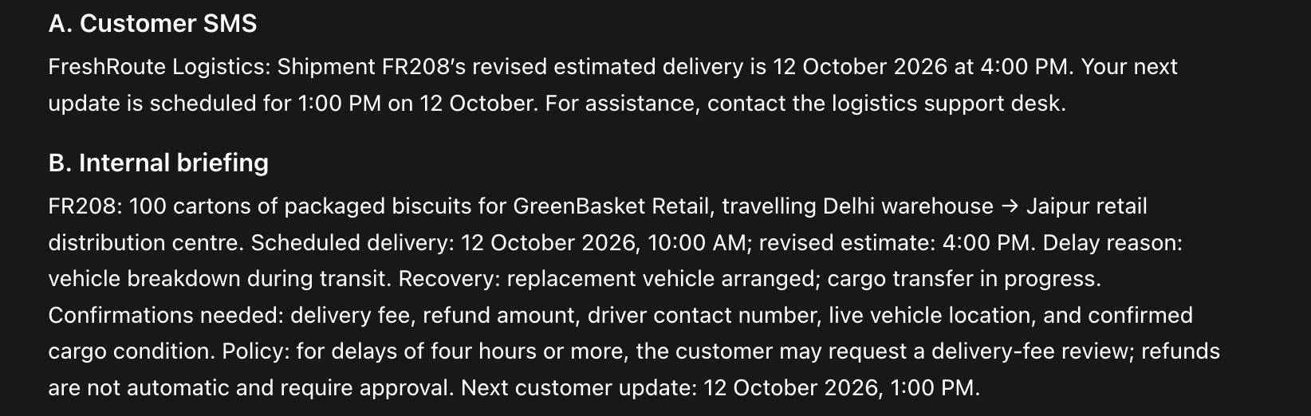

Observation:
The customer SMS is short and easy to understand, while the internal briefing provides more operational details for the warehouse team. Both outputs use the same shipment facts without adding unverified information.

Why the two audiences need different messages:
Customers need a brief and clear update about delivery timing and support, while the warehouse team needs more operational details to coordinate the shipment and confirm missing information.

Live Change Challenge
Prompt used - Update the previous customer email and SMS using this new information: the revised estimated delivery is now 6:00 PM on 12 October 2026, and the next customer update is now 3:00 PM on 12 October 2026. Preserve all other supplied facts and the existing policy. Remove the outdated 4:00 PM and 1:00 PM timings. Keep the revised delivery time clearly identified as an estimate, not a guarantee. Do not invent any new information.

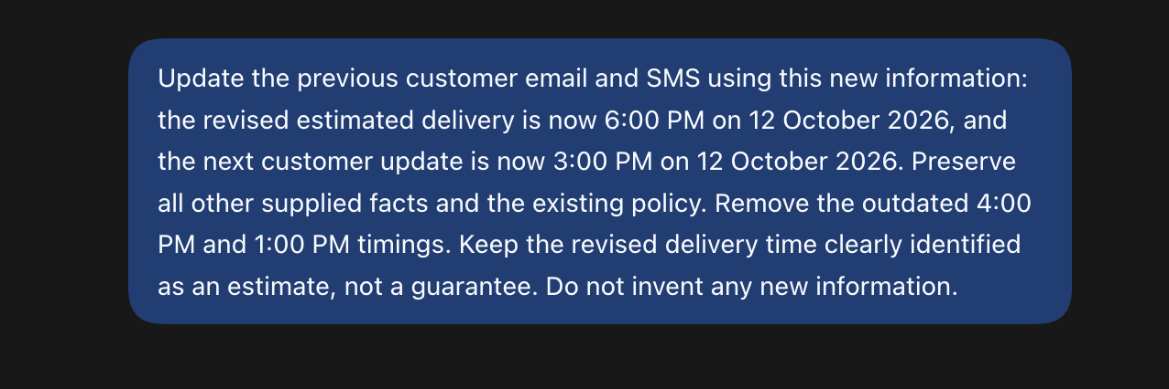

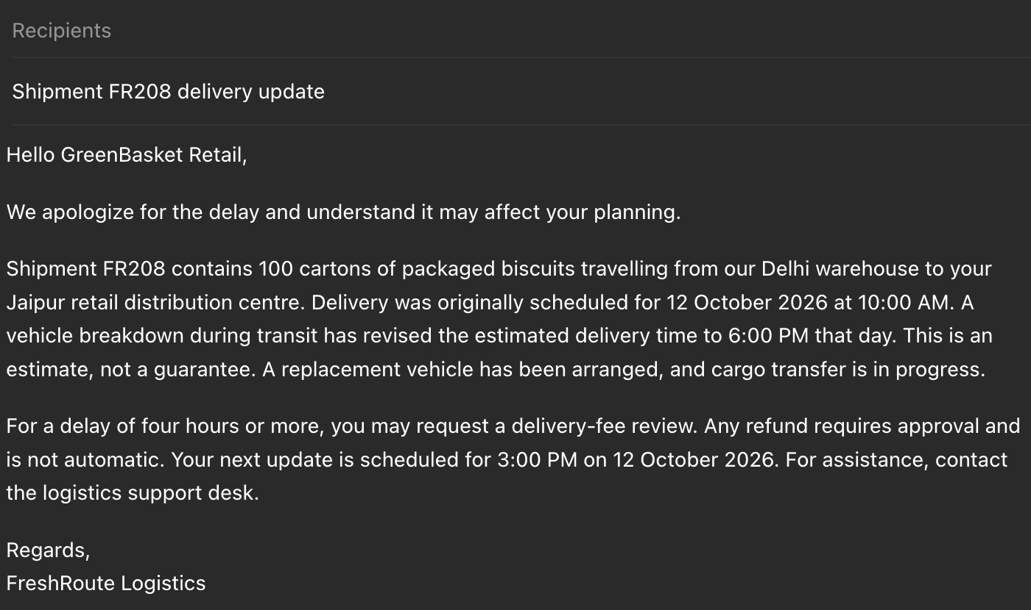
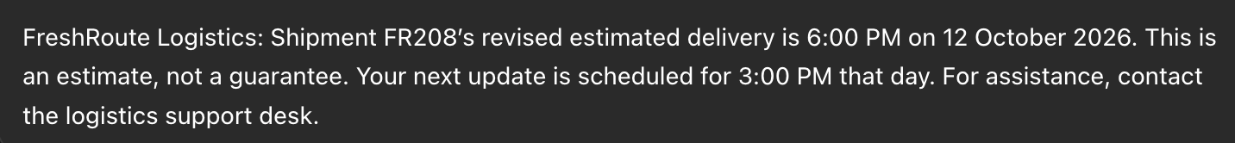

Explanation / Verification
I checked the updated email and SMS against the new information. The revised estimated delivery was changed to 6:00 PM and the next customer update was changed to 3:00 PM. I also checked that the outdated timings were removed and that the delivery time was still presented as an estimate, not a guarantee.

7. Manual Verification

Detail to check | Correct information | Correct in final output? | Correction made, if needed
Shipment ID | FR208 | Yes | None
Revised estimated delivery | 12 October 2026, 6:00 PM | Yes | None
Next update | 12 October 2026, 3:00 PM | Yes | None
Delay reason, if mentioned | Vehicle breakdown during transit | Yes | None
Recovery action, if mentioned | Replacement vehicle arranged; cargo transfer in progress | Yes | None
Refund policy, if mentioned | Fee review may be requested; refund requires approval | Yes | None
Cargo condition | Not confirmed | Yes | None
Delivery wording | Estimated arrival; no guarantee | Yes | None

8. Reflection
1. Which prompting strategy produced the most useful output, and why?
Context and constraints produced the most useful output because the AI had the complete shipment information and clear instructions about what it could and could not include. This made the response more accurate and reliable.
2. How did adding context change the initial response?
Adding context changed the response from a generic delay message into a specific customer communication. It included the shipment ID, delivery timings, delay reason, recovery action and next update.
3. What unsupported claim did you identify, or what potential error did you check for?
I checked for unsupported information such as a refund amount, vehicle location, driver contact number and cargo condition. I made sure the AI did not present the estimated delivery time as a guarantee.
4. How did the customer message differ from the internal briefing?
The customer message was short, clear and focused on delivery information and the next update. The internal briefing included more operational details such as shipment quantity, route, recovery action and information that still needed confirmation.
5. What must a human verify before sending these messages?
A human should verify the shipment ID, delivery timings, delay reason, recovery action and company policy before sending the messages. They should also check that the AI has not invented information or made promises that the company cannot guarantee.

9. AI-Use Declaration

AI-Use Declaration
“I used ChatGPT to generate and refine draft communication. I checked the outputs against the supplied fictional facts and policy. The observations, verification and reflection are my own work.”

